LCD 3310 (PCD 8544) ROM Image Generation using FastLCD
By Fandi Gunawan
http://fandigunawan.wordpress.com
fandigunawan@gmail.com

Tool used : FastLCD by Bojan I. (attached) 
Text editor : notepad, wordpad or Notepad++ (highly recommended)

This method is actually intended to be used with my PCD8544 driver which is available from http://fandigunawan.wordpress.com

First set LCD size o 84 x 48 (since pcd 8544 is a monochrome LCD with size 84 x 48)
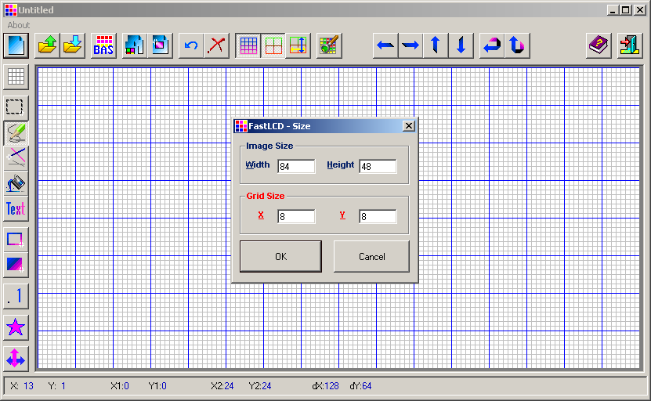

Open BMP file (attached) 
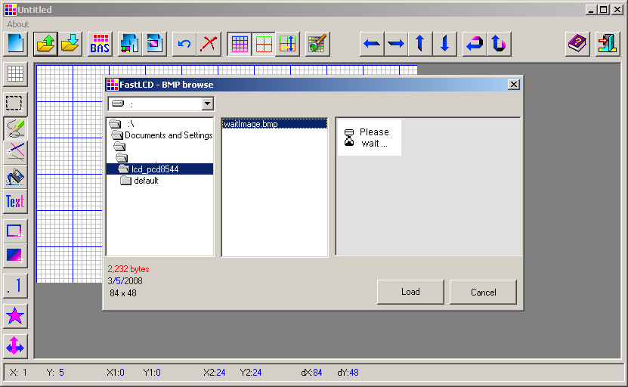

You might just paste it or stretch the image is the image size is not suitable 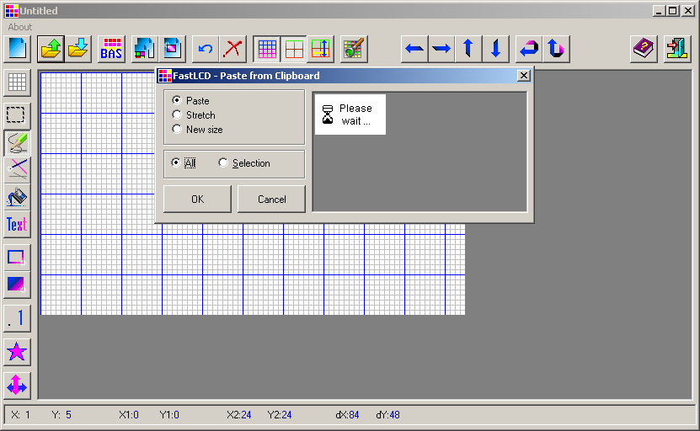

OK we are half way now.

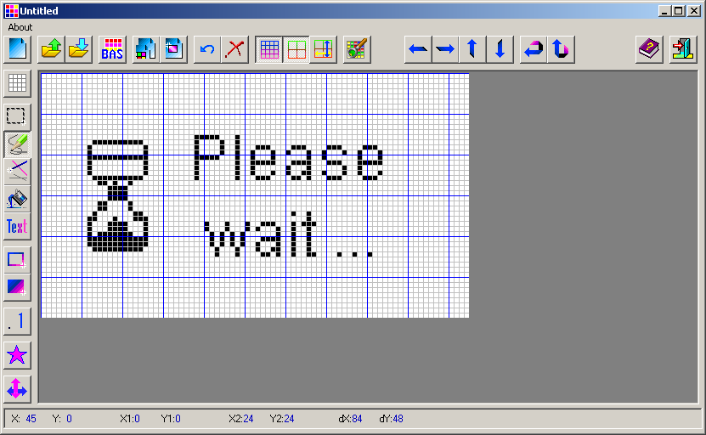

Then click “BAS” to generate BAS file (actually this program is used to generate BASIC file, but we will see how to do a trick to make it C file ) and don’t forget to save as “Image”
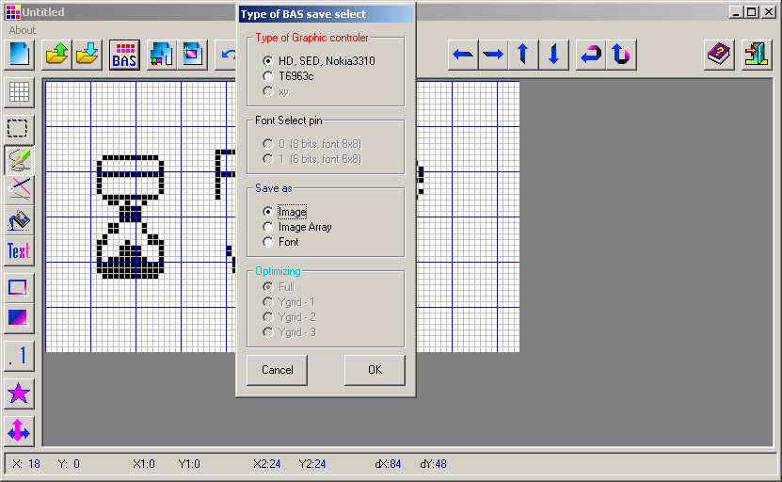

Open the generated *.BAS file using your favorite text editor.
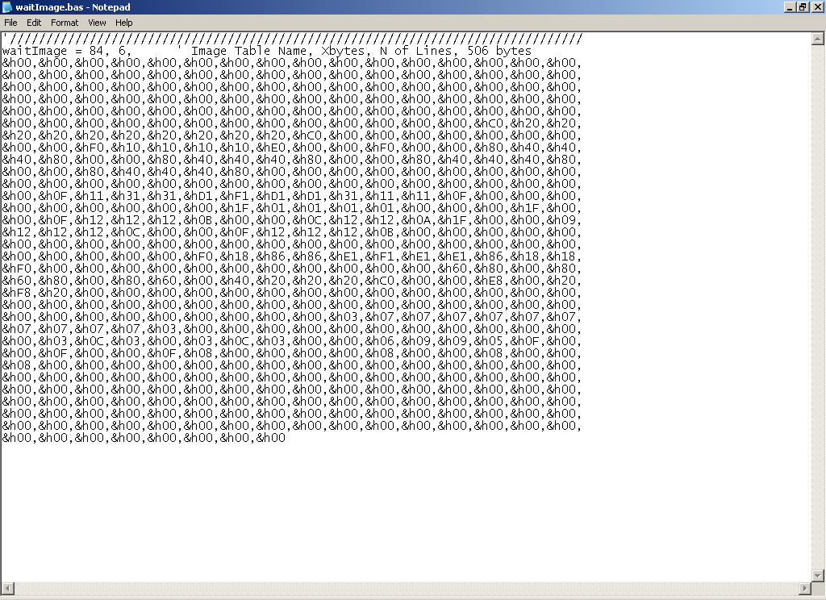
Remove 1st line and the 2nd line then select replace menu from your text editor and replace &h with 0x

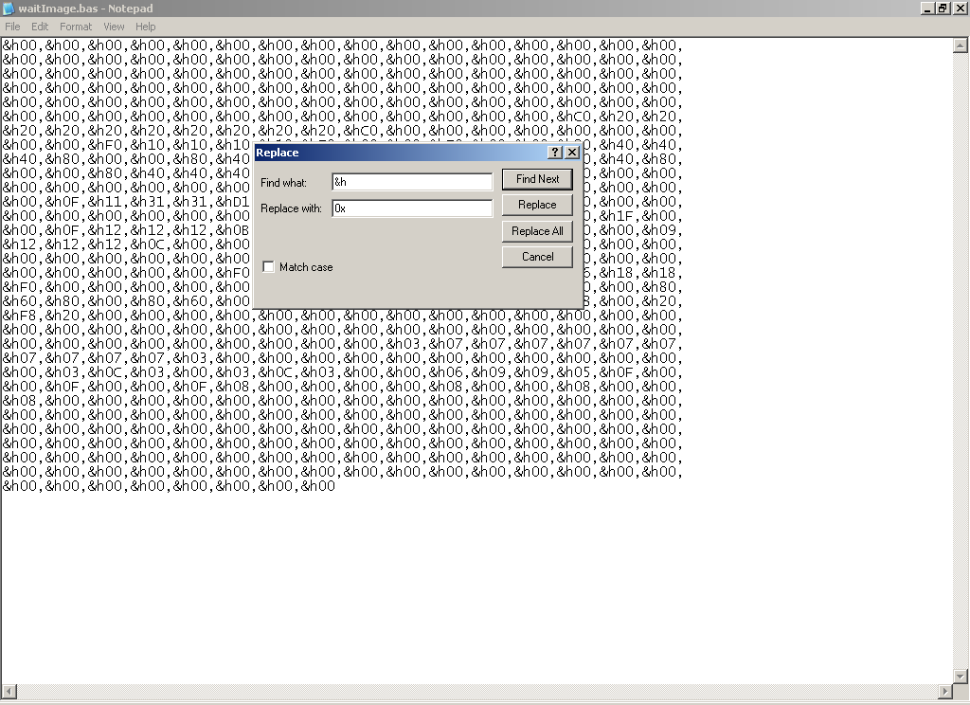

File of waitImage.BAS is attached here : 
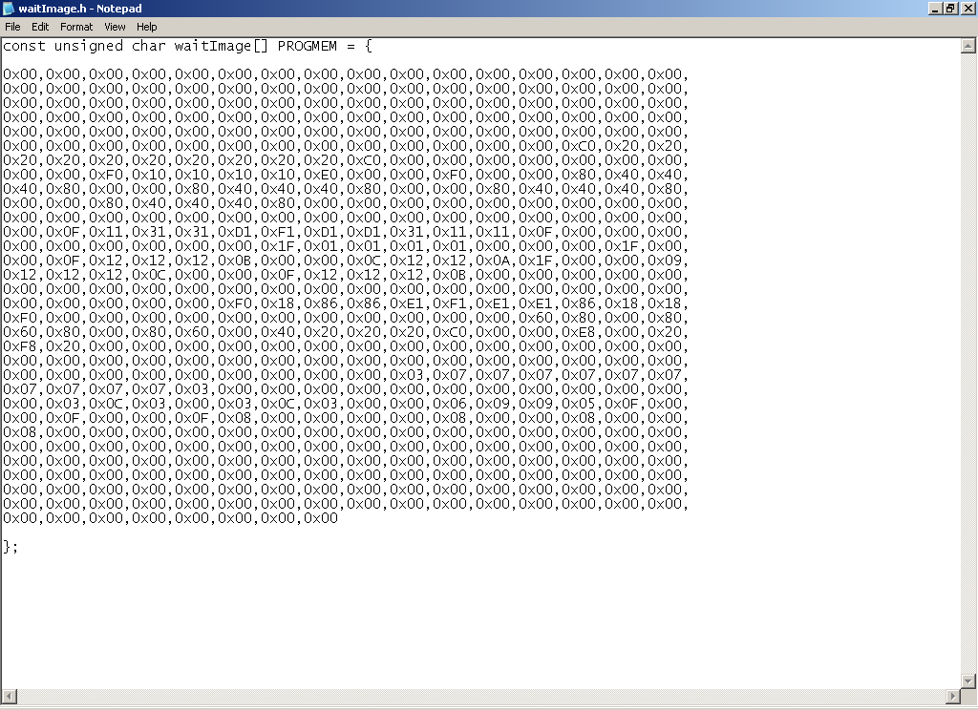

Then, add this line :
const unsigned char waitImage[] PROGMEM = {

and add this at the end of file

};

Then save it to filename.h (C header file)

Note : PROGMEM is used to save the array of image to flash ROM.
File waitImage.h (contains ROM image) is attached here : 

OK, you can now add the file to your project :p

